**به نام خدا**

**محمد‌امین چینی‌فروشان اصفهانی** **97521207**

**فاز سوم پروژه**

نمودار ER به صورت زیر است.

همچنین فایل html مربوطه هم ارسال شده است.

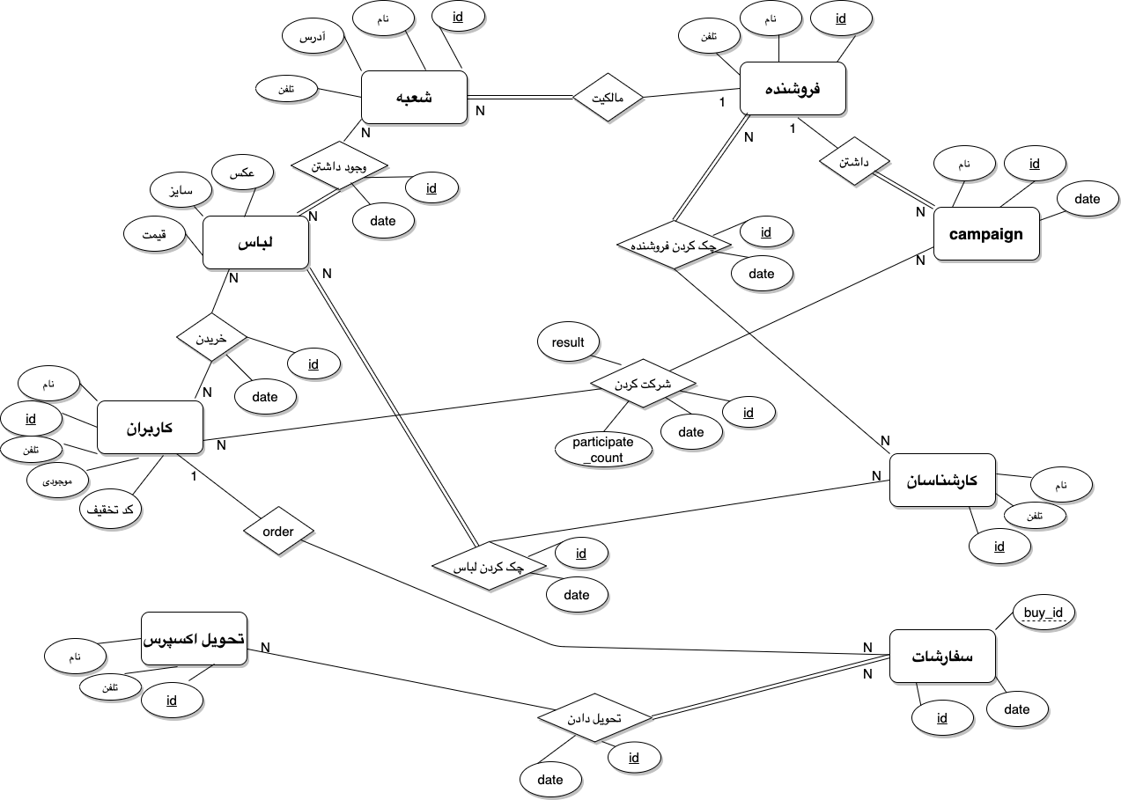

HEADERS:

فروشنده :

Seller(seller_id, seller_name, telephone)

شعبه:

Branch(branch_id, seller_id, Branch _name, Branch _address, telephone)

لباس:

Cloth(c_id, pic, size, price)

کاربران:

Users(user_id, user _name, telephone, supply, dis_codes)

کمپین:

Campaign(camp_id, seller_id, camp_name, creation_date)

کارشناسان:

Checkers(checker_id, checker_name, telephone)

خریدن:

Buy(buy_id, user_id, c_id, buy_date)

سفارشات:

Orders(order_id, buy_id, user_id, order_date)

تحویل اکسپرس:

Express(ex_id, ex_name , telephone)

تحویل دادن:

Recieve(recieve_id, ex_id, order_id, receive_date)

شرکت کردن:

Participate(p_id, user_id, camp_id, p_date, patrticipate_count, result)

چک کردن لباس:

Cloth_check(clc_id, c_id, checker_id, clc_date)

چک کردن فروشنده:

Celler_check(sec_id, seller_id, checker_id, sec_date)

وجود داشتن:

Be_exist(c_id, branch_id)

جداول:

Seller

|  |  |  |  |  |  |  |  |
| --- | --- | --- | --- | --- | --- | --- | --- |
| Attribute Name | Type | Nullable | Is unique | PK | FK | Constraint1 | Constraint2 |
| Seller_id | Integer | No | Yes | Yes | No |  |  |
| Seller_name | text | No | No | No | No |  |  |
| telephone | Varchar(10) | No | No | No | No |  |  |

Branch

|  |  |  |  |  |  |  |  |
| --- | --- | --- | --- | --- | --- | --- | --- |
| Attribute Name | Type | Nullable | Is unique | PK | FK | Constraint1 | Constraint2 |
| branch_id | Integer | No | Yes | Yes | No |  |  |
| seller_id | Integer | No | Yes | Yes |  |  |
| Branch_name | text | No | No | No | No |  |  |
| Branch_address | text | No | No | No | No |  |  |
| telephone | Varchar(10) | No | No | No | No |  |  |

Cloth

|  |  |  |  |  |  |  |  |
| --- | --- | --- | --- | --- | --- | --- | --- |
| Attribute Name | Type | Nullable | Is unique | PK | FK | Constraint1 | Constraint2 |
| c_id | Integer | No | Yes | Yes | No |  |  |
| pic | text | No | No | No | No |  |  |
| Price | Integer | No | No | No | No |  |  |

Users

|  |  |  |  |  |  |  |  |
| --- | --- | --- | --- | --- | --- | --- | --- |
| Attribute Name | Type | Nullable | Is unique | PK | FK | Constraint1 | Constraint2 |
| user_id | Integer | No | Yes | Yes | No |  |  |
| user _name | text | No | No | No | No |  |  |
| telephone | Varchar(10) | No | No | No | No |  |  |
| supply | Integer | No | No | No | No |  |  |
| dis_codes | jsonb | Yes | No | No | No |  |  |

Campaign

|  |  |  |  |  |  |  |  |
| --- | --- | --- | --- | --- | --- | --- | --- |
| Attribute Name | Type | Nullable | Is unique | PK | FK | Constraint1 | Constraint2 |
| camp_id | Integer | No | Yes | Yes | No |  |  |
| seller-id | Integer | No | Yes | Yes |  |  |
| Camp_name | text | No | No | No | No |  |  |
| Creation_date | date | No | No | No | No |  |  |

Checkers

|  |  |  |  |  |  |  |  |
| --- | --- | --- | --- | --- | --- | --- | --- |
| Attribute Name | Type | Nullable | Is unique | PK | FK | Constraint1 | Constraint2 |
| Checker_id | Integer | No | Yes | Yes | No |  |  |
| Checker_name | text | No | No | No | No |  |  |
| telephone | Varchar(10) | No | No | No | No |  |  |

Buy

|  |  |  |  |  |  |  |  |
| --- | --- | --- | --- | --- | --- | --- | --- |
| Attribute Name | Type | Nullable | Is unique | PK | FK | Constraint1 | Constraint2 |
| buy_id | Integer | No | No | Yes | No |  |  |
| User_id | Integer | No | Yes | Yes |  |  |
| C_id | Integer | No | Yes | Yes |  |  |
| Buy_date | date | No | No | No | No |  |  |

Orders

|  |  |  |  |  |  |  |  |
| --- | --- | --- | --- | --- | --- | --- | --- |
| Attribute Name | Type | Nullable | Is unique | PK | FK | Constraint1 | Constraint2 |
| order_id | Integer | No | Yes | Yes | No |  |  |
| Buy_id | Integer | No | Yes | Yes |  |  |
| User_id | Integer | No | Yes | Yes |  |  |
| Order_date | date | No | No | No | No |  |  |

Express

|  |  |  |  |  |  |  |  |
| --- | --- | --- | --- | --- | --- | --- | --- |
| Attribute Name | Type | Nullable | Is unique | PK | FK | Constraint1 | Constraint2 |
| ex_id | Integer | No | Yes | Yes | No |  |  |
| Ex_name | text | No | No | No | No |  |  |
| telephone | Varchar(10) | No | No | No | No |  |  |

Receiving

|  |  |  |  |  |  |  |  |
| --- | --- | --- | --- | --- | --- | --- | --- |
| Attribute Name | Type | Nullable | Is unique | PK | FK | Constraint1 | Constraint2 |
| Receive_id | Integer | No | Yes | Yes | No |  |  |
| ex_id | Integer | No | Yes | Yes |  |  |
| order_id | Integer | No | Yes | Yes |  |  |
| Receive_date | date | No | No | No | No |  |  |

Participate

|  |  |  |  |  |  |  |  |
| --- | --- | --- | --- | --- | --- | --- | --- |
| Attribute Name | Type | Nullable | Is unique | PK | FK | Constraint1 | Constraint2 |
| p_id | Integer | No | Yes | Yes | No |  |  |
| User_id | Integer | No | Yes | Yes |  |  |
| Camp_id | Integer | No | Yes | Yes |  |  |
| P_date | date | No | No | No | No |  |  |
| Participate_count | Integer | No | No | No | No | 0 to 3 per month |  |
| Result | Boolean | No | No | No | No |  |  |

Cloth_check

|  |  |  |  |  |  |  |  |
| --- | --- | --- | --- | --- | --- | --- | --- |
| Attribute Name | Type | Nullable | Is unique | PK | FK | Constraint1 | Constraint2 |
| Clc_id | Integer | No | Yes | Yes | No |  |  |
| C_id | Integer | No | Yes | Yes |  |  |
| Checker_id | Integer | No | Yes | Yes |  |  |
| Clc_date | date | No | No | No | No |  |  |

Seller_check

|  |  |  |  |  |  |  |  |
| --- | --- | --- | --- | --- | --- | --- | --- |
| Attribute Name | Type | Nullable | Is unique | PK | FK | Constraint1 | Constraint2 |
| sec_id | Integer | No | Yes | Yes | No |  |  |
| seller_id | Integer | No | Yes | Yes |  |  |
| Checker_id | Integer | No | Yes | Yes |  |  |
| Sec_date | date | No | No | No | No |  |  |

Be_exist

|  |  |  |  |  |  |  |  |
| --- | --- | --- | --- | --- | --- | --- | --- |
| Attribute Name | Type | Nullable | Is unique | PK | FK | Constraint1 | Constraint2 |
| C_id | Integer | No | Yes | Yes | yes |  |  |
| Branch_id | Integer | No | Yes |  |  |